

Faculty of Information Technology
Department of Software Engineering
Database Management System – 13435

“Mini Query Execution Engine with
Join Algorithm Evaluation”

Instructor: Dr. Ahmad Altamimi

Joanne Zawaideh – 20230064
Salman Al-Zoabi – 20230667

Introduction
This project simulates the process of query execution, which includes parsing, scanning, filtering, joining and projecting CSV-based tables, using Java. The program writes the resulting table on a text file, as well as performance metrics, such as execution time and number of blocks accessed, for a query as complex as a query of the form:
SELECT A.x, B.y FROM A, B WHERE A.id = B.id AND A.value > 50;
The performance results are used to compare the Nested Loop Join and Hash Join algorithms.

Performance Analysis
Assumptions
Number of buffers available $n_{B}=7$
Block Size $B=4000 bytes$
Record Size $R=40 bytes$
Number of records per block $bfr=100$
File Organization: Fixed-sized unspanned records
Query:
SELECT Orders.order_id, Customers.customer_id
FROM Customers, Orders
WHERE Customers.customer_id = Orders.customer_id
AND Orders.amount < 5000;

Experimental Results
Dataset size: 10,000 records per table
- Nested Loop Join:
 | Execution Time (ms) | # of Blocks Accessed
Scan Operation | 141 | 200
Select Operation | 25 | 100
Join Operation | 2724 | 1151
Project Operation | 3 | 51
- Hash Join:
 | Execution Time (ms) | # of Blocks Accessed
Scan Operation | 141 | 200
Select Operation | 25 | 100
Join Operation | 85 | 151
Project Operation | 3 | 51
Dataset size: 20,000 records per table
- Nested Loop Join:
 | Execution Time (ms) | # of Blocks Accessed
Scan Operation | 173 | 400
Select Operation | 25 | 200
Join Operation | 21804 | 4100
Project Operation | 6 | 100
- Hash Join:
 | Execution Time (ms) | # of Blocks Accessed
Scan Operation | 173 | 400
Select Operation | 25 | 200
Join Operation | 105 | 300
Project Operation | 6 | 100
Dataset size: 30,000 records per table
- Nested Loop Join:
 | Execution Time (ms) | # of Blocks Accessed
Scan Operation | 299 | 600
Select Operation | 33 | 300
Join Operation | 72306 | 9149
Project Operation | 13 | 149
- Hash Join:
 | Execution Time (ms) | # of Blocks Accessed
Scan Operation | 299 | 600
Select Operation | 33 | 300
Join Operation | 181 | 449
Project Operation | 13 | 149

Graph
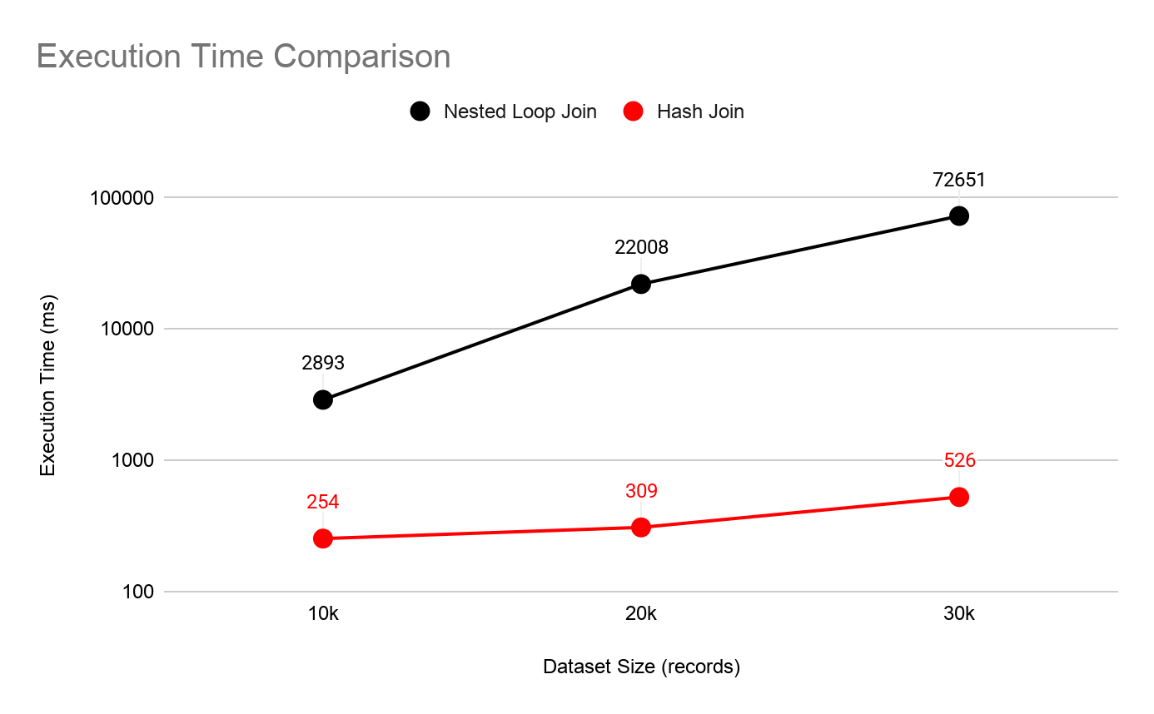

Performance Evaluation
Both Nested Loop Join and Hash Join algorithms were run on the same query and produced the same results, but there was a significant difference in execution time and block accesses. In Nested Loop Join, chunks of blocks in one table are fetched and compared with every block in another table, causing many blocks to be scanned repeatedly and the execution time to be greater. Whereas, in Hash Join, a single pass on both tables is enough to perform the join. Consequently, as the dataset size increases, Hash Join scales better because it becomes more costly to scan blocks repeatedly in Nested Loop Join. Therefore, Hash Join has much lower execution time and requires less disk I/O to produce the same result.
Conclusion
The project successfully produced correct results on queries of the following forms:
- SELECT * FROM A;
- SELECT A.x FROM A;
- SELECT A.x, B.y FROM A, B WHERE A.value < 200;
- SELECT A.x, B.y FROM A, B WHERE A.name = ‘Ahmad’;
- SELECT A.x, B.y FROM A, B WHERE A.id = B.id;
- SELECT A.x, B.y FROM A, B WHERE A.id = B.id AND A.value > 50;
The experimental results showed how each join algorithm’s performance is affected by dataset size. Hash Join proved to be more efficient than Nested Loop Join for equi-join queries on large datasets, requiring both less time and less block accesses.

